COMP7630 Group Project Report

Movie Recommendation base on IMBD

19403844 Deng Guoquan

Abstract

3,Rating Prediction Task

3.1, Data collection

The first thing I need to consider is data of collection. IMBD website is not complex HTML structure website, so it is suitable to crawl information from IMDB though it is long request time to get response from IMDB in the mainland of China. I use a framework call Scrapy, Unlike the normal tool of python for example requests package, scrapy can make even 64 request in one second, and it is asynchronous so when it faces the block which may waste a lone time, it can solve other tasks at first. Instead of using package beautifulsoup, I use package lxml which can be used to parse xml structure directly and faster than beautifulsoup. The data crawling from the website will be stored by easy data base sqlite3. Before crawling the information, template data base which used to store the status information can not be ignore. I create a template table to store the request and response status for each url I crawl preventing loss information when some bug or connection break happen during crawling data. If some thing wrong appear, I can continue the task from the break point again. Since IMBD has not IP limit so I do not use proxy. But in order to avoid detection from website, each request should be pack with different user-agent and remove the cookie information.

After nearly one day crawling, I crawl basic information of 11556 movies. Two table haven been created to stored all data, here I will provide a short brief.

1. Movie Table: title, move_id, Grading, Vote, Rating, Language, Country, Release_Data, Genres, Production_company, Director, Writter, Cast, Summary, Keywords. It contain 11556 movies’ basic information.

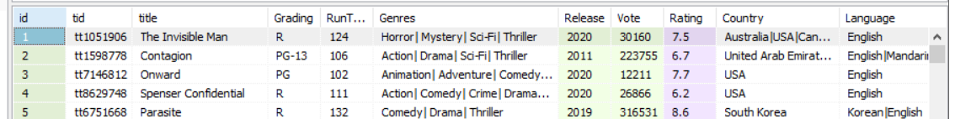

1. UserRating Table: userName, movie_id, rating. It contain 1258702 rating records.

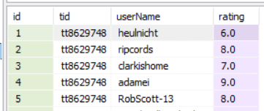

3.2, Data cleaning

Because I focus on rating prediction task, so the first step for me is to clean the rating data. The first step of data cleaning is to remove the row with empty or null. Since the data I can crawl is small compare with the whole data from the website, what is more, there are not any explicit relationship between pages I crawl, so the data set is very sparse. Some movies just have only one rating, some client just rating one movie, all these data is noise and most of them are out of real situation because I can not gain complete data. So I remove all these data. Some clients give all the movies they watch the same rating, I also remove all these data. Now I get the data based on distribution shown below:

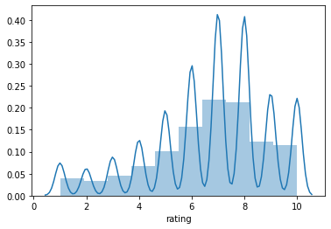

Since the computation of my computer is not good enough, I sample higher density data from this data set, so the distribution of mini data set I use is shown below:

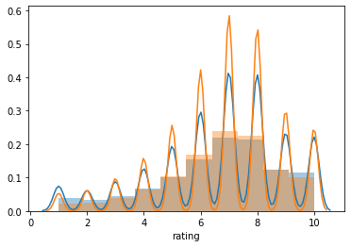

Extract suitable data set is very important, you will need long time and larger model to over fit the challenge data set, to some degree, if the data set contain a certain percentage of noise data, even the complex and larger model can not be trained well.

3.3, Estimation method

Estimation consist of two part: 1, using RMSE and MAE as the error function, calculate the RMSE and MAE between real rating and predict rating, RMSE using for training, MAE using for directly compare. 2, Choosing RMSE and MAE between mean rating group by user and real rating as the base line of models. In this data set, the base line is 1.46. The formula to gain the base line shown below:



Reason of user’s mean rating as base line: to some degree, the base line contain some prior information of clients, only the clients are interested in the movie, they will watch it, if they do not like the movie, they will not even watch it or give a rating. So that is why we can see the distribution of data set is right skew and imbalanced.

3.4, Model Exploration

3.4.1 Cosine similarity model:



it is a easy model, assume similar movie for same user having the same rating value. Value of cosine distance is -1 to 1, because the movie totally different with the estimated movie will not provide negative value so I compress the cosine distance into 0 to 1. And for the purpose to simple the calculation process, I regular the vector length of embedding into 1.



It sound reasonable, but there are some disadvantage in the model. 1, the predicting value can not excess or less than the history highest point and lowest point. 2, movie with similarity of 1 get the highest score is not reasonable, assume some one love topic like Action, if a movie contain more content about action it should be given a higher rating although the similarity is not 1.

The result I got for this model shown below, y-axis is MAE error.

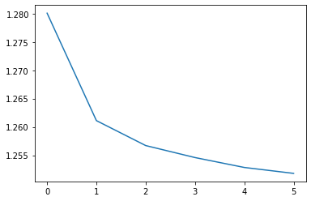

3.4.2 Advance similarity model

For the purpose of resolving the disadvantage of Cosine similarity model, I use a embedding linear regression model. Imaging movie as embedding of size 50, each point of embedding represent percentage of one topic, more percentage of topic client liking, the rating will be higher.



The MAE cost can be seen below:

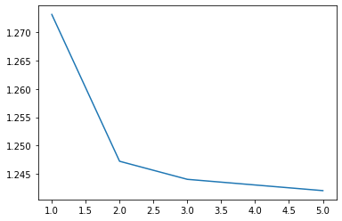

Unfortunately there is no improvement for this model.

3.4.3 Collaborative Filtering

Collaborative Filtering is normal method, I test user-based collaborative Filtering and item-based collaborative Filtering. And for both two algorithm, I test two type of distance function, one kind of distance function A just consider the Intersection set of rated movies from two client, the other kind of distance function B, I consist the union set of movies which has been rated by the compared two customers.

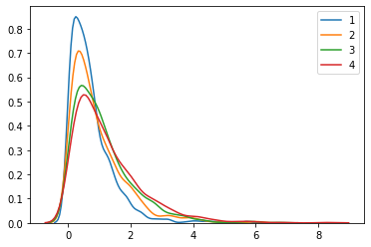

Here is the MAE cost distribution, line 1 represent user-based collaborative Filtering with distance function B, line 2 represent item-based collaborative Filtering with distance function B, line 3 represent user-based collaborative Filtering with distance function A, line 4 represent item-based collaborative Filtering with distance function A. The following expect cost are 0.73, 0.93, 1.10, 1.24.

The cause of the collaborative Filtering contain the mean rating of client, so it work better than it is in the real world. Mean rating of client will provide prior information. In collaborative Filtering, we assume mean of rating represent bias of client though it is nor correct after I try to use rating value minus user’s mean rating as parameters of distance function and it fail.

After removing prior information the distribution of MAE will become:

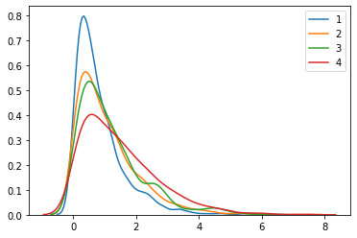

3.4.4 Simple Correlation Model

Simple model can make a good prediction. In this model, I suppose the there is a correlation matrix between each pair of movie, somebody love one movie may love the other specific one. But when the number of movies is larger, it will exponentially increasing, the size of matrix equal to . but we can use a embedding space to represent this matrix because this matrix is symmetry:



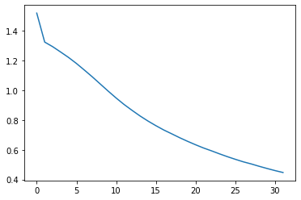

3.4.5 Content Base model

Some content and basic information is also very useful. I choose genres as the content of movie, there are 36 genres in this data set. The first step is define the user profile and movie feature haven been show below:



When I have movie feature and user profile, we need to create cross feature.



Because the computation process (1) of cross feature is not symmetry, I need to transform the cross feature matrix into a symmetry matrix, so I use formula (2), and then select the upper triangle of this matrix as the feature.

For the purpose of training the model, I adjust the train data set, I classify all the rating which larger or equal 8 to be true positive recommendation as 2, all the rating which less or equal 5 as true negative recommendation labeled 1, the other are 0. And the distribution of data set become:

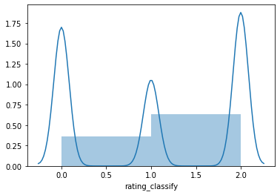

In order to solve the imbalance problem, I use re-sample method to ensure the positive samples and negative samples are both 50%. for this binary classification problem, two modes have been trained, logistic regression model with accuracy 63.07%. Random forest model: 82.06%. Some interest and importance cross feature shown here:

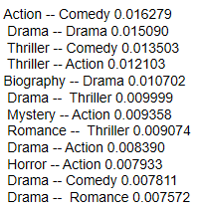

Reference：

1, 《推荐系统实践》，项亮编著， ISBN-978-7-115-28158-6,2012.6

2, 《Algorithms of the Intelligent Web 2nd-Edition》version 9, Douglas G.Mcllwraith, Haralambos Marmanis, Dmitry Babenko, 2016 copyright manning publication

1. 《Building Machine Learning Systems with Python》,Willi Richert, Luis Pedro Coelho, ISBN-978-7-115-35682-6,2014.7
2. 《The BellKor Solution to the Netflflix Grand Prize》，Yehuda Koren，2009.8

5, 《MATRIX FACTORIZATION TECHNIQUES FOR RECOMMENDER SYSTEMS》，Yehuda Koren，Yahoo Research， Robert Bell and Chris Volinsky, AT&T Labs-Research.